Palash Bajpai

Spring Boot

Table of Contents
1. Introduction to Spring Boot 2
🔹 Important Features of Spring Boot 2
🔹 Spring Boot Vs Spring 3
🔹 Hello World API 4
2. Web Service 6
🔹 Types of Web Services 7
3. REST API with Spring Boot 9
🔹 Swagger Documentation 15
🔹 Spring Boot Actuators 16
4. Spring JPA 17
🔹 JPQL(Java Persistence Query Language) 22
🔹 Derived Query Methods 23
5. Spring Configuration and profiling 24
🔹 application.properties and application.yml 24
🔹 External Configuration 25
🔹 Profiles 26
6. Spring AOP 28
🔹 Core AOP Concepts 28
🔹 SLF4J 32

1. Introduction to Spring Boot

Spring Boot is an opinionated framework built on top of the Spring Framework to simplify application development by:
- Eliminating boilerplate configurations
- Providing default behaviors (auto-configuration)
- Embedding web servers (like Tomcat)
- Enabling production-ready features out-of-the-box
- Focuses on convention over configuration.
"Opinionated" means Spring Boot makes smart decisions for you (e.g., which configurations to use) so you can get started quickly and only override when needed.

🔹 Important Features of Spring Boot

1. Auto-Configuration:

Based on classpath scanning, it configures your app automatically. Behind the scenes, it uses @EnableAutoConfiguration and conditionals like @ConditionalOnClass, @ConditionalOnMissingBean.
Example: If you have spring-boot-starter-data-jpa and H2 in your classpath, it automatically configures: DataSource, EntityManager, Hibernate dialect ,H2 Console

@SpringBootApplication = @Configuration + @EnableAutoConfiguration + @ComponentScan
Reads from:
- META-INF/spring.factories
- Checks conditions using @Conditional* annotations

2. Embedded Web Servers:

Runs apps directly using embedded servers. No need for WAR or external server deployment.

3. Spring Initializer:

Scaffold a new project instantly: Visit: https://start.spring.io/ . Instantly sets up project with correct directory structure and config.
4. Starter Dependencies:

Reduces complexity by bundling compatible dependencies together.
<!--Instead of this-->
<dependency>spring-core</dependency>
<dependency>spring-context</dependency>
<dependency>spring-webmvc</dependency>

<!--Use this:-->
<dependency>
<groupId>org.springframework.boot</groupId>
<artifactId>spring-boot-starter-web</artifactId>
</dependency>

5. Spring Boot Actuator:

Enables health checks, metrics, env info etc.

6. Spring Boot DevTools:

Live reload and automatic restarts during development.

7. External Configuration via application.yml or application.properties:

Supports multiple environments like:
# application-dev.yml
server:
port: 8081
spring:
datasource:
url: jdbc:h2:mem:testdb

🔹 Spring Boot Vs Spring

Feature | Spring Framework | Spring Boot
Setup | Manual (XML or Java) | Auto-config via starters
Web Server | External (Tomcat) | Embedded
Deployment | WAR file | Executable JAR
Config | Verbose, scattered | Centralized (application.yml)
Dependency Management | Manual | Starter POMs
Monitoring Tools | Custom setup | Built-in via Actuator
Learning Curve | Steep | Gentle (opinionated defaults)
Productivity | Medium | Very high

🔹 Hello World API

CODE EXAMPLE:
1. Got to Spring initializer and initiate the project
Go to: https://start.spring.io .
Add spring boot web dependency:
<dependency>
<groupId>org.springframework.boot</groupId>
<artifactId>spring-boot-starter-web</artifactId>
</dependency>
spring-boot-starter-web: Includes everything for a web app:
- Spring MVC
- Embedded Tomcat
- Jackson (for JSON)
- Logging, etc.
We get this code:

@SpringBootApplication
public class StudentManagementApplication {
public static void main(String[] args) {
SpringApplication.run(StudentManagementApplication.class, args);
}
}
@SpringBootApplication is a meta-annotation:
- Combines @Configuration, @EnableAutoConfiguration, and @ComponentScan.
SpringApplication.run(...) bootstraps the app:
- Starts the embedded Tomcat server
- Scans the classpath
- Initializes Spring context

2. Creating Hello world controller
import org.springframework.web.bind.annotation.GetMapping;
import org.springframework.web.bind.annotation.RestController;
@RestController
public class HelloController {
@GetMapping("/hello")
public String hello(){
return "Hello World";
}
}
@RestController = @Controller + @ResponseBody
- Makes the method return JSON/text directly instead of rendering a view.
@GetMapping("/hello")
- Maps the HTTP GET request to /hello path.
- The method returns a plain text "Hello, World!".

3. Can change the port if needed: by changing in application.properties
spring.application.name=StudentManagement
# Server port (default is 8080)
server.port=8080

4. Output
Now go to: http://localhost:8080/hello
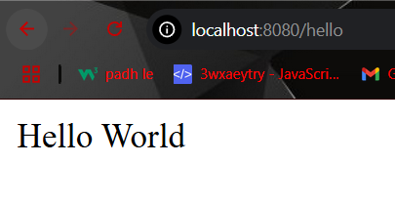

Component | Role
@SpringBootApplication | Marks the main Spring Boot app class and sets up context
SpringApplication.run | Starts the app and embedded server
@RestController | Indicates a REST API controller
@GetMapping | Maps GET requests to methods
application.properties | Used for configuration like ports, paths, etc.
Embedded Tomcat | Auto-configured HTTP server

2. Web Service

A web service is a standardized way of enabling communication and data exchange between two software applications over a network (typically the Internet). These applications can be written in different programming languages and run on different platforms. Web services use protocols and standards to facilitate interoperability.
- Eliminating boilerplate configurations
- Providing default behaviors (auto-configuration)
- Embedding web servers (like Tomcat)
- Enabling production-ready features out-of-the-box
Key Characteristics:
- Platform-Independent: Web services enable applications written in different languages (e.g., Java, Python, .NET) to communicate seamlessly. Also communication should be platform-independent (eg XML, Json).
- Protocol-Based Communication: Allows communication over a network and uses protocols like HTTP, HTTPS, and SOAP for exchanging data.
- Loosely Coupled: The client and server are not tightly bound; they communicate through interfaces defined by the service.
- Interoperability: Web services ensure interoperability across systems with different architectures.
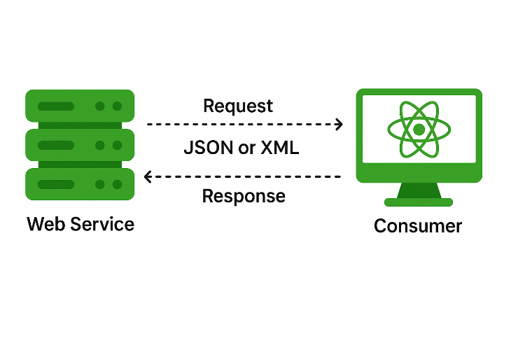
Key Components:
- Request: Input to a web service
- Response: Output from the web service
- Message Exchange Format (Payload Format): XML or JSON for exchanging data.
- Endpoints: URL where the web services are accessible.
- Service Provider (Server): Entity providing the Web Service.
- Service Consumer: Entity consuming the Web Service.

🔹 Types of Web Services

1. Soap ( Simple Object Access Protocol)
SOAP is a protocol for exchanging structured information using XML over HTTP, SMTP, or other transport protocols.
Features:
- Strict standards for message format.
- Built-in error handling.
- Provides higher security (WS-Security).
Advantages:
- Ideal for enterprise-level applications requiring reliability.
- Supports multiple transport protocols.
Disadvantages:
- Verbose and complex to implement.
- Slower due to XML-based payload.
Example: A banking service providing secure account details.

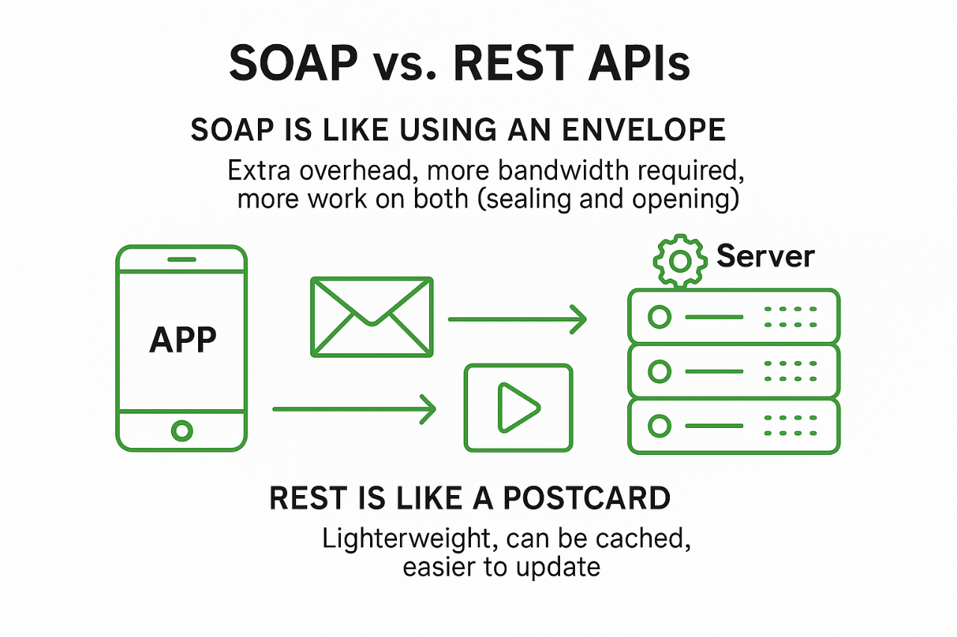

2. REST (Representational State Transfer) Web Services
REST is an architectural style for designing lightweight web services using standard HTTP methods.
Features:
- Stateless communication.
- Supports multiple formats (XML, JSON, etc.).
Advantages:
- Lightweight and faster.
- Easier to integrate with modern web applications.
- Broadly used for APIs.
Disadvantages:
- Lacks built-in security mechanisms (depends on HTTPS).
Example: A REST API for retrieving weather data.

Feature | REST (Representational State Transfer) | SOAP (Simple Object Access Protocol)
Protocol | Typically uses HTTP | Uses any protocol (HTTP, SMTP, TCP, etc.)
Message Format | Usually JSON (can also use XML, HTML, plain text) | Strictly XML
Interface Style | Resource-based (URLs represent resources) | Operation-based (uses services and functions)
Flexibility | Lightweight and flexible | Heavy and rigid
Performance | Generally faster and uses less bandwidth | Slower due to XML parsing and additional headers
Standards Compliance | Less standardized (no strict rules) | Highly standardized (WSDL, XSD, WS-Security, etc.)
Ease of Use | Easy to use and test via browser or tools like Postman | Harder to test without dedicated tools like SoapUI
Security | Relies on HTTPS and OAuth for security | Built-in support for WS-Security (encryption, signing)
Error Handling | HTTP status codes (e.g., 404, 500) | Uses SOAP Fault messages
Data Types Support | Limited to HTTP-friendly types (text, JSON, XML, etc.) | Supports complex data types via XML Schema
Tooling Support | Easy integration with modern web tools (React, Angular, etc.) | Strong support in enterprise environments and legacy tools
Service Description | Can use OpenAPI/Swagger for documentation | Uses WSDL (Web Services Description Language)
Caching | Supports caching (using HTTP GET) | No inherent caching mechanism
Use Cases | Web/mobile APIs, microservices, public APIs | Enterprise systems, banking, payment gateways

3. REST API with Spring Boot

A RESTful API is an API that adheres to REST constraints, making it stateless, cacheable, layered, and uniform.
Key REST Concepts:
- Resource: Anything that can be named (e.g., a User, Order, etc.)
- URI: Identifies a resource (e.g., /api/users/1)
- Representation: JSON or XML structure sent to the client
- Statelessness: No session is stored on the server
- HTTP Verbs: Mapped to CRUD operations
  - GET → Read
  - POST → Create
  - PUT → Update
  - DELETE → Delete

CODE EXAMPLE:
1. We will create Student Management System supporting CRUD operation
Go to: https://start.spring.io .
Add spring boot web dependency:

<dependency>
<groupId>org.springframework.boot</groupId>
<artifactId>spring-boot-starter-web</artifactId>
</dependency>
<dependency>
<groupId>org.projectlombok</groupId>
<artifactId>lombok</artifactId>
<optional>true</optional>
</dependency>

Project Lombok is a Java library that helps developers eliminate boilerplate code like Getters and Setters, Constructors, equals() and hashCode(), toString(), Builders etc.
It does this using annotations that generate code at compile time, making your Java classes cleaner and easier to maintain.
Annotation | One-liner Explanation
@Getter | Generates getter methods for all or selected fields.
@Setter | Generates setter methods for all or selected fields.
@ToString | Automatically generates a toString() method.
@EqualsAndHashCode | Generates equals() and hashCode() methods based on fields.
@Data | A shortcut for @Getter, @Setter, @ToString, @EqualsAndHashCode, and @RequiredArgsConstructor.
@NoArgsConstructor | Generates a no-argument constructor.
@AllArgsConstructor | Generates a constructor with parameters for all fields.
@RequiredArgsConstructor | Generates a constructor for final and @NonNull fields only.
@Builder | Implements the builder pattern for easy object construction.
@Value | Makes the class immutable (final fields, private constructor, only getters).
@Slf4j | Adds a Logger object named log using SLF4J logging API.
@NonNull | Generates a null-check for the parameter in constructors or methods.

Project Structure
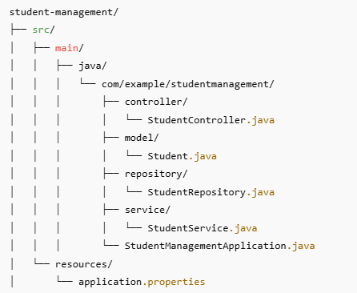

2. Basic File which initiate SpringBootApplication

package com.example.studentManagement;
import org.springframework.boot.SpringApplication;
import org.springframework.boot.autoconfigure.SpringBootApplication;
@SpringBootApplication // Combines @Configuration, @EnableAutoConfiguration, and @ComponentScan
public class StudentManagementApplication {
public static void main(String[] args) {
SpringApplication.run(StudentManagementApplication.class, args);
}
}

@SpringBootApplication: Convenience annotation that auto-configures Spring Boot app and scans for components in the same package or sub-packages.

3. Creating Student.java file in model
package com.example.studentManagement.model;
public class Student {
private Long id;
private String name;
private String email;
private int age;
// Constructors
public Student() {}
public Student(Long id, String name, String email, int age) {
this.id = id;
this.name = name;
this.email = email;
this.age = age;
}
// Getters and Setters
public Long getId() { return id; }
public void setId(Long id) { this.id = id; }
public String getName() { return name; }
public void setName(String name) { this.name = name; }
public String getEmail() { return email; }
public void setEmail(String email) { this.email = email; }
public int getAge() { return age; }
public void setAge(int age) { this.age = age; }
}

Or Can use Lombok for same, sometimes Lombok gives issues in intellij. Remember to install Lombok plugin in intellij while using it.

package com.example.studentManagement.model;
import lombok.AllArgsConstructor;
import lombok.Data;
import lombok.NoArgsConstructor;
@Data // Generates getters, setters, toString, equals, and hashCode
@NoArgsConstructor // Generates a no-argument constructor
@AllArgsConstructor // Generates an all-arguments constructor
public class Student {
private Long id;
private String name;
private String email;
private int age;
}

- @Data : A shortcut for @Getter, @Setter, @ToString, @EqualsAndHashCode, and @RequiredArgsConstructor (except for final fields only). It’s most commonly used to make a POJO clean and concise.
- @NoArgsConstructor: Automatically generates a public no-argument constructor (public Student() {}), required by frameworks like Spring and Jackson.
- @AllArgsConstructor: Generates a constructor with all fields as parameters. E.g., public Student(Long id, String name, String email, int age).

4. Creating Repository class, can later be replaced with jpa.
@Repository: Indicates this class deals with data (like a DAO). Spring detects it and makes it a bean.

package com.example.studentManagement.repository;
import com.example.studentManagement.model.Student;
import org.springframework.stereotype.Repository;
import java.util.*;
@Repository // Marks class as a Spring-managed data component
public class StudentRepository {
//like a temp db
private final Map<Long, Student> studentDb = new HashMap<>();
private Long currentId = 3L;
//adding some sample data
{
studentDb.put(1L, new Student(1L, "Palash","palash@gmail.com",32));
studentDb.put(2L, new Student(2L, "Raj","raj@gmail.com",23));
}
public List<Student> findAll() {
return new ArrayList<>(studentDb.values());
}
public Optional<Student> findById(Long id) {
return Optional.ofNullable(studentDb.get(id));
}
public Student save(Student student) {
if (student.getId() == null) {
student.setId(currentId++);
}
studentDb.put(student.getId(), student);
return student;
}
public void deleteById(Long id) {
studentDb.remove(id);
}
public boolean existsById(Long id) {
return studentDb.containsKey(id);
}
}
5. Creating Service layer, Here we will have all logics of how to delete, update, fetch etc.
- @Service: Marks this class as a business service.
- @Autowired: Lets Spring inject dependencies automatically (in this case, the repository).

package com.example.studentManagement.service;
import com.example.studentManagement.model.Student;
import com.example.studentManagement.repository.StudentRepository;
import org.springframework.beans.factory.annotation.Autowired;
import org.springframework.stereotype.Service;
import java.util.List;
import java.util.Optional;
@Service // Business logic layer component
public class StudentService {
@Autowired // Injects StudentRepository bean
private StudentRepository repository;
//to get all students
public List<Student> getAllStudents() {
return repository.findAll();
}
public Student getStudentById(Long id) {
return repository.findById(id).orElse(null);
}
public Student createStudent(Student student) {
return repository.save(student);
}
public Student updateStudent(Long id, Student updatedStudent) {
if (repository.existsById(id)) {
updatedStudent.setId(id);
return repository.save(updatedStudent);
}
return null;
}
public boolean deleteStudent(Long id) {
if (repository.existsById(id)) {
repository.deleteById(id);
return true;
}
return false;
}
}

6. Creating Controller layer, Here we will have all APIs used by our system
- @RestController: Marks this class as a Controller

package com.example.studentManagement.controller;
import com.example.studentManagement.model.Student;
import com.example.studentManagement.service.StudentService;
import org.springframework.beans.factory.annotation.Autowired;
import org.springframework.web.bind.annotation.*;
import java.util.List;
@RestController // @Controller + @ResponseBody
@RequestMapping("/students") // Base path for all endpoints
public class StudentController {
@Autowired
private StudentService service;
@GetMapping
public List<Student> getAllStudents() {
return service.getAllStudents();
}
@GetMapping("/{id}")
public Student getStudentById(@PathVariable Long id) {
return service.getStudentById(id);
}
@PostMapping
public Student createStudent(@RequestBody Student student) {
return service.createStudent(student);
}
@PutMapping("/{id}") //This is for update
public Student updateStudent(@PathVariable Long id, @RequestBody Student student) {
return service.updateStudent(id, student);
}
@DeleteMapping("/{id}") //This is for delete
public String deleteStudent(@PathVariable Long id) {
return service.deleteStudent(id) ? "Deleted" : "Student not found";
}
}
- @RestController: Tells Spring this class handles REST API and returns data (not views). Combines @Controller + @ResponseBody for REST API responses
- @RequestMapping("/api/students"): Sets base URL for all methods.
- @GetMapping, @PostMapping, @PutMapping, @DeleteMapping: Maps HTTP methods to handler methods.
- @PathVariable: Extracts {id} from the URL.
- @RequestBody: Converts incoming JSON into a Student object automatically.

Rest APIs
HTTP Method | URL | Description
GET | /students | Get list of all students.
GET | /students/{id} | Get a student by their ID.
POST | /students | Create a new student.
PUT | /students/{id} | Update student details by ID.
DELETE | /students/{id} | Delete a student by ID.

🔹 Swagger Documentation

Swagger/OpenAPI is a REST API documentation tool that auto-generates UI from code annotations.
Benefits:
- Developer-friendly interface to test APIs
- Self-documenting code
- Client SDK generation

Depencency:
<dependency>
<groupId>org.springdoc</groupId>
<artifactId>springdoc-openapi-starter-webmvc-ui</artifactId>
<version>2.2.0</version> <!-- or latest -->
</dependency>

Go to link: http://localhost:8080/swagger-ui.html
And we get

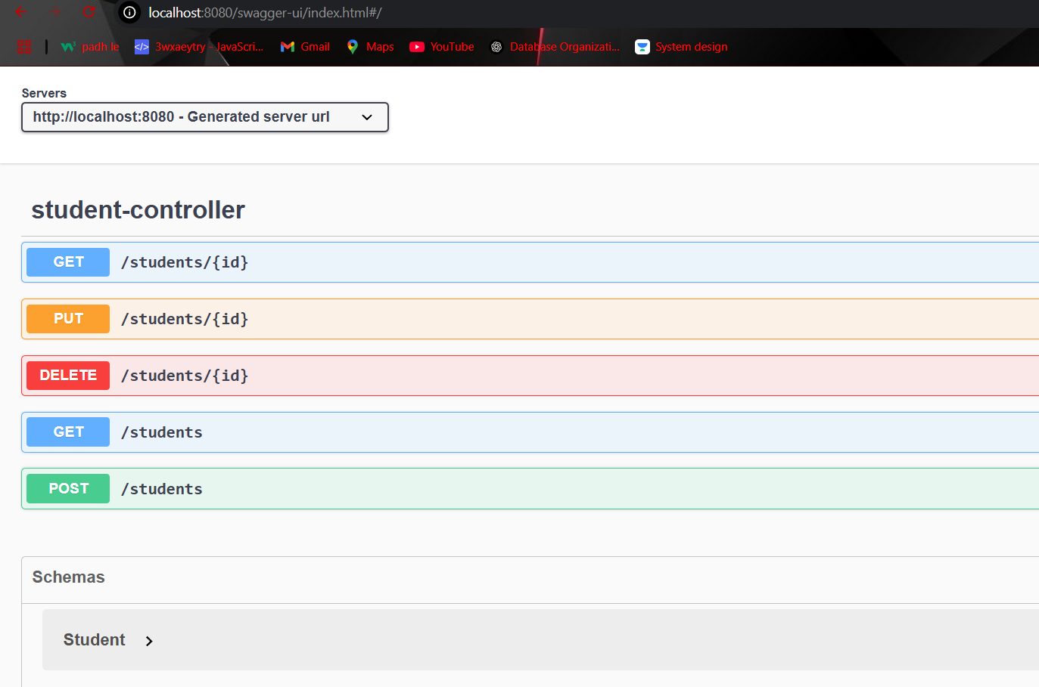

🔹 Spring Boot Actuators

Spring Boot Actuator is a sub-project of Spring Boot that provides production-ready features for monitoring and managing your application. It exposes built-in endpoints over HTTP or JMX to give insights into app’s internal state - like health, metrics, environment, and more.
Benefits:
- Monitor app health and status
- Track metrics (e.g., memory, CPU, request count)
- View system environment properties
- Manage app beans, mappings, logs, etc.
- Integrates well with monitoring tools like Prometheus, Grafana, New Relic

Depencency:
<dependency>
<groupId>org.springframework.boot</groupId>
<artifactId>spring-boot-starter-actuator</artifactId>
</dependency>

Also in application.properties add
#For actuator
management.endpoints.web.exposure.include=*
management.endpoint.shutdown.enabled=true

Connections:
URL | Purpose
http://localhost:8080/actuator | List of all available actuator endpoints
http://localhost:8080/actuator/health | App health status (UP or DOWN)
http://localhost:8080/actuator/info | Custom app info from properties
http://localhost:8080/actuator/metrics | Exposes metrics like memory, threads
http://localhost:8080/actuator/env | Environment variables
http://localhost:8080/actuator/mappings | All controller request mappings
http://localhost:8080/actuator/beans | All loaded Spring beans
http://localhost:8080/actuator/loggers | Logging levels and controls

Use cases:
If your app crashes, hangs, or misbehaves in production:
- Use /actuator/health to check DB/connection issues
- Use /actuator/metrics to see memory/CPU problems
- Use /actuator/env to view loaded environment profiles
- Use /actuator/loggers to increase debug log level at runtime

4. Spring JPA

Spring Data JPA is the easiest way to persist and query data using standard Java classes without writing SQL.
Spring Data JPA is a Spring project that simplifies the use of JPA (Java Persistence API) for object-relational mapping (ORM). It removes boilerplate code and provides powerful abstractions to interact with databases using repositories.

Key Concepts:
Term | Description
Entity | A class mapped to a database table using annotations
Repository | An interface to abstract data access and query operations
Service | A layer between controllers and repositories for business logic
Transaction | A unit of work that must succeed or fail as a whole

🔹 Entity
An Entity is a Java class mapped to a database table using @Entity.

Important Annotations
@Entity | Declares a class as a JPA entity, if table don’t exist it can create a table in db
@Id | Specifies the primary key
@GeneratedValue | Auto-generates primary key values
@Column | Maps a field to a table column
@Table | (Optional) Specifies custom table name

@Entity
@Table(name = "users")
public class User {
@Id
@GeneratedValue(strategy = GenerationType.IDENTITY)
private Long id;
@Column(nullable = false)
private String name;
private String email;
}
Repository Layer
Repositories extend JpaRepository or CrudRepository to provide CRUD and pagination features.

Interface | Description
CrudRepository<T, ID> | Basic CRUD (save, findById, delete)
JpaRepository<T, ID> | Extends CrudRepository with more features like pagination, flush, batch

public interface UserRepository extends JpaRepository<User, Long> {
List<User> findByName(String name);
}
Here in JpaRepository<T,ID> , replace T with Entity name and ID is data type of primary Key of that Entity.

CODE EXAMPLE:
We will update Student Management System with JPA code.

1. Add maven dependency for jpa and postgresSql driver

<dependency>
<groupId>org.springframework.boot</groupId>
<artifactId>spring-boot-starter-data-jpa</artifactId>
</dependency>
<dependency>
<groupId>org.postgresql</groupId>
<artifactId>postgresql</artifactId>
<version>42.7.2</version>
</dependency>

2. Setup data base (studentdb) from pgadmin
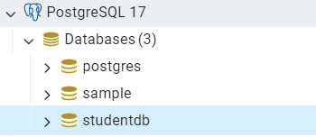

Add setup in application.properties.
- spring.jpa.hibernate.ddl-auto: allows to perform ddl, like if Entity table is not present, create a table in db.
- spring.jpa.show-sql=true: shows sql executed in console.
# PostgreSQL Configuration
spring.datasource.url=jdbc:postgresql://localhost:5432/studentdb
spring.datasource.username=postgres
spring.datasource.password=1234
# Hibernate Configuration
spring.jpa.database-platform=org.hibernate.dialect.PostgreSQLDialect
spring.jpa.hibernate.ddl-auto=update
spring.jpa.show-sql=true

3. Mark Student.java as Entity
package com.example.studentManagement.model;
import jakarta.persistence.*;
import java.lang.*;
@Entity
public class Student {
@Id //Mark id as primary key
@GeneratedValue(strategy = GenerationType.IDENTITY)
private Long id;
private String name;
private String email;
private int age;
public Student(){} // Required by JPA
public Student(Long id, String name, String email, int age) {
this.id = id;
this.name = name;
this.email = email;
this.age = age;
}
public Long getId() {
return id;
}
public void setId(Long id) {
this.id = id;
}
public int getAge() {
return age;
}
public void setAge(int age) {
this.age = age;
}
public String getEmail() {
return email;
}
public void setEmail(String email) {
this.email = email;
}
public String getName() {
return name;
}
public void setName(String name) {
this.name = name;
}
}
JPA (Java Persistence API) uses reflection to instantiate entity objects, and it requires a no-argument constructor to create instances when loading data from the database.
4. Mark StudentRepository.java and extend JpaRepository

package com.example.studentManagement.repository;
import com.example.studentManagement.model.Student;
import org.springframework.stereotype.Repository;
import org.springframework.data.jpa.repository.JpaRepository;
@Repository
public interface StudentRepository extends JpaRepository<Student, Long> {
}

JpaRepository is a Spring Data interface that extends CrudRepository and PagingAndSortingRepository to provide a rich set of methods for working with JPA (Java Persistence API) entities — without writing any boilerplate code.

Feature | Description
🔁 CRUD Operations | Built-in methods like save(), findById(), findAll(), delete()
🔍 Query Derivation | Auto-generates queries from method names like findByName()
🔢 Pagination & Sorting | Easily paginate and sort using Pageable, Sort
💬 Custom Queries | Write JPQL or native SQL using @Query
📦 Batch Operations | saveAll(), deleteAllInBatch(), flush() for efficiency
📌 Transactional Support | Works seamlessly with Spring’s @Transactional
🧠 Intelligent Proxy Generation | Spring auto-generates implementation using proxies at runtime

Common build in methods for JpaRepository

Method | Description
save(entity) | Save or update an entity
findById(id) | Get one entity by primary key
findAll() | Get all entities
deleteById(id) | Delete entity by ID
count() | Count total records
existsById(id) | Check if entity exists
findAll(Pageable) | Paginate results
findAll(Sort) | Sort results

5. Calling the repo methods via service

@Service
public class StudentService {
@Autowired
StudentRepository repo;
public List<Student> getStudents(){
return repo.findAll();
}
public Student getStudentById(Long id){
return repo.findById(id).orElseThrow(() -> new RuntimeException("Student not found"));
}
public Student addStudent(Student student){
return repo.save(student);
}
public void removeStudent(Long id){
repo.deleteById(id);
}
public void updateStudentById(Long id, Student student) {
Student existing = getStudentById(id);
existing.setName(student.getName());
existing.setEmail(student.getEmail());
existing.setAge(student.getAge());
repo.save(existing);
}
}

6. Controller class will need no change, just few changes in some return type

@RestController
@RequestMapping("/students")
public class StudentController {
@Autowired StudentService service;
@GetMapping
public List<Student> getAllStudents(){
return service.getStudents();
}
@GetMapping("/{id}")
public Student getAllStudents(@PathVariable Long id){
return service.getStudentById(id);
}
@PostMapping
public Student addUser(@RequestBody Student student){
return service.addStudent(student);
}
@DeleteMapping("/{id}")
public void deleteStudent(@PathVariable Long id){
service.removeStudent(id);
}
@PutMapping("/{id}")
public void updateStudent(@PathVariable Long id, @RequestBody Student student){
service.updateStudentById(id,student);
}
}

🔹 JPQL(Java Persistence Query Language)

JPQL (Java Persistence Query Language) is a platform-independent object-oriented query language defined as part of JPA (Java Persistence API). Unlike SQL which queries tables and columns, JPQL queries entities and their properties.
- SQL: operates on tables and columns
- JPQL: operates on Java classes (entities) and fields

Syntax
SELECT s FROM Student s WHERE s.name = :name

- Student s: refers to the Entity class
- s.name: is the field in the entity (not a DB column)
- :name: is a named parameter

Eg: Lets say , till now we were searching by id, but wants to search by name. So we can write query for same using JPQL. Remember, repo is interface here
@Repository
public interface StudentRepository extends JpaRepository<Student, Long> {
// JPQL Query
@Query("SELECT s FROM Student s WHERE s.name = :name")
List<Student> findByName(String name);
}

- @Query: Defines a custom JPQL query

Aspect | JPQL | Native SQL
Query Type | Entity-based | Table/Column-based
Portability | Highly portable across DBs | Tied to specific SQL dialects
Use-case | Common queries, simple joins | Complex joins, DB functions
Annotation | @Query("JPQL here") | @Query(value="SQL", nativeQuery=true)

🔹 Derived Query Methods
Spring Data JPA can automatically implement queries for you by analyzing the method name in the repository interface. These methods are called query derivation methods.

Eg: in place of writing this:
@Query("SELECT s FROM Student s WHERE s.name = :name")
List<Student> findByName(String name);

We can simple write:
List<Student> findByName(String name);
You don’t need to write @Query unless you need custom logic, spring Data JPA will automatically generate the correct JPQL at runtime: SELECT s FROM Student s WHERE s.name = ?1
How does Spring do this?
Spring parses the method name using the pattern: findBy<FieldName>. Then it maps it to the corresponding entity field. For example:
- findById(Long id) → SELECT s FROM Student s WHERE s.id = ?1
- findByName(String name) → SELECT s FROM Student s WHERE s.name = ?1
- findByAgeGreaterThan(int age) → SELECT s FROM Student s WHERE s.age > ?1

Common Keywords used
Keyword | Description
And, Or | Combine conditions
Is, Equals | Equality
Between | Range queries
LessThan | < comparison
GreaterThan | > comparison
Like, Containing | Pattern matching (LIKE in SQL)
OrderBy | Sorting results
Not, IsNot | Negation

List<Student> findByName(String name);
List<Student> findByNameAndAge(String name, int age);
List<Student> findByNameContaining(String keyword);
List<Student> findByAgeGreaterThanEqual(int age);

5. Spring Configuration and profiling

🔹 application.properties and application.yml
Spring Boot uses application.properties or application.yml files in the src/main/resources directory to centralize configuration.
You can define:
- Server properties (port, context path)
- Database connection details
- Logging levels
- Profiles
- Custom key-value configs

Key differences:
application.properties | application.yml
Key-Value format | YAML hierarchy format
Easier for scripts | More readable for nested configs
key=value | key: value

Example:-
1. application.properties

server.port=8081
server.servlet.context-path=/api
spring.application.name=MyApp
logging.level.org.springframework=DEBUG

2. application.yml

server:
port: 8081
servlet:
context-path: /api
spring:
application:
name: MyApp
logging:
level:
org.springframework: DEBUG

Notes:
- Default file is application.properties.
- You can use both .properties and .yml but not for the same keys (avoid confusion).
- Use .yml for hierarchical data (e.g., database, logging).
- Spring Boot will load application.properties or application.yml automatically from the classpath.

Important properties

1. You can set the port and context path of your application easily using:

server.port=8085
server.servlet.context-path=/service

This makes your app accessible at: http://localhost:8085/service

🔹 External Configuration
Spring Boot supports externalizing configuration, which means values can come from:
- application.properties or application.yml
- Command-Line Arguments
- Environment Variables
- @Value or @ConfigurationProperties
This allows dynamic configuration for environments like dev, test, or prod.

Command Line Example:

java -jar demo.jar --server.port=9095 --custom.message="Deployed in QA"

Environment Variable Example (Linux/macOS):

export SERVER_PORT=7070
export SPRING_PROFILES_ACTIVE=prod

Spring will automatically map SERVER_PORT to server.port.

Notes:
- Command-line args override all.
- Environment variables are useful in containers (Docker/Kubernetes).
- Useful in CI/CD pipelines for dynamic deployments.

Priority order of configuration: (Highest to Lowest Priority):
- Command-line arguments
- Environment variables
- application-<profile>.properties
- application.properties
- Default values in code

🔹 Profiles
We use profiling in Spring Boot to define and manage multiple configurations (e.g., dev, test, prod) for different environments, allowing the application to load specific beans or settings based on the active profile.
Profiles help you separate environment-specific logic, like using an in-memory database in development and a real database in production.

Uses Cases of profiling:
- Use different database configurations for dev and prod
- Use mock beans for testing and real beans for production
- Enable or disable debugging tools only in dev profile
- Load different application properties per environment
How to create different profiles:
Create 2 different application.properties, each for dev and prod

1. application-dev.properties:
server.port=8080
spring.datasource.url=jdbc:mysql://localhost:3306/devdb
spring.datasource.username=devuser
spring.datasource.password=devpass
2. application-prod.properties:
server.port=80
spring.datasource.url=jdbc:mysql://prod-db:3306/proddb
spring.datasource.username=produser
spring.datasource.password=prodpass
Activate required profile:
1. set in default application.properties

spring.profiles.active=dev

2. via command line

java -jar demo.jar --spring.profiles.active=prod

@Profile
Creating beans based on profile. The annotation @Profile("dev") tells Spring to only load that bean or configuration class when the dev profile is active.

@Configuration
@Profile("dev")
public class DevConfig {
@Bean
public DataSource devDataSource() {
return new H2DataSource(); // In-memory DB for dev
}
}

This bean will only be created if: spring.profiles.active=dev
You can create multiple profile or even negate profile:

@Profile({"dev", "test"})
@Profile("!prod") // Loaded if profile is NOT "prod"

6. Spring AOP

AOP (Aspect-Oriented Programming) is a programming paradigm in Spring used to modularize cross-cutting concerns — like logging, security, transactions, exception handling - that are scattered across many classes (called cross-cutting concerns).

- Spring AOP allows you to separate such concerns from business logic using aspects, making code cleaner and more maintainable.
- Spring AOP allows you to inject additional behaviors before, after, or around method execution in Spring-managed beans — without modifying the actual method code.

Use Cases of AOP:

Use Case | Why AOP Is Ideal
Logging | Keep logs cleanly separate from business logic
Performance Metrics | Measure method execution time
Security | Check user permissions before execution
Transactions | Add @Transactional declaratively
Retry Mechanisms | Wrap methods to retry on failure
Audit Trails | Track changes to data or method calls

🔹 Core AOP Concepts

Aspect | A module that encapsulates behaviors affecting multiple classes (a concern).
Join Point | A point during execution — like method call or exception — where an aspect can be applied.
Advice | The action taken by an aspect at a join point. Example: @Before, @After, @Around.
Pointcut | A predicate that matches join points. Used to define where advice should be applied.
Weaving | Linking aspects with other application types or objects at runtime or compile time.
Proxy | Spring AOP uses proxies to implement AOP. The original bean is wrapped in a proxy object.
CODE EXAMPLE:
We will add AOP to our Student Management Application

1. Add Dependency

<dependency>
<groupId>org.springframework.boot</groupId>
<artifactId>spring-boot-starter-aop</artifactId>
</dependency>

2. Create an aspect for logging, here we will target service classes.

Created 2 aspect files, for now will try LoggingAspect
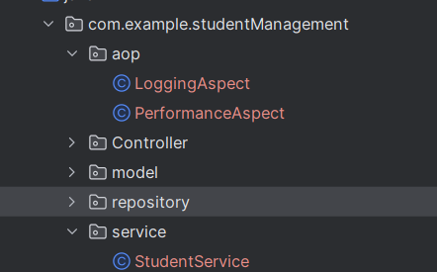

Below code will run before any method in service class runs.
@Aspect
@Component
public class LoggingAspect {
@Before("execution(* com.example.studentManagement.service.*.*(..))")
public void logBeforeMethodCall() {
System.out.println("🚀 Logging before method call...");
}
}

Output:
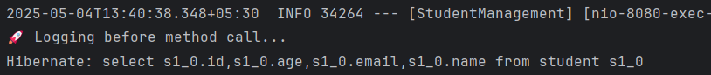

@Before("execution(* com.example.service.*.*(..))")

This is a pointcut expression saying:
- Match all methods
- In all classes under com.example.service
- With any arguments
Different Pointcut Expression:
Expression | Meaning
execution(* com.example..*.*(..)) | Match any method in any class in package com.example or its subpackages
execution(public * *(..)) | Match any public method
execution(* *(..)) | Match any method
execution(* *..*Service.*(..)) | Match all methods in classes ending with Service

Different Advices:

Advice Type | Annotation | Purpose
Before | @Before | Run code before method
After | @After | Run code after method
AfterReturning | @AfterReturning | Run code after successful method execution
AfterThrowing | @AfterThrowing | Run code when method throws exception
Around | @Around | Run code before and after method, even control execution

Using different aspects:
@Aspect
@Component
public class LoggingAspect {
@Before("execution(* com.example.studentManagement.service.StudentService.*(..))")
public void beforeAdvice() {
System.out.println("Before method");
}
@After("execution(* com.example.studentManagement.service.StudentService.*(..))")
public void afterAdvice() {
System.out.println("After method");
}
@AfterReturning("execution(* com.example.studentManagement.service.StudentService.*(..))")
public void afterReturningAdvice() {
System.out.println("After returning from method");
}
@AfterThrowing("execution(* com.example.studentManagement.service.StudentService.*(..))")
public void afterThrowingAdvice() {
System.out.println("After throwing exception");
}
}

3. Creating an aspect for testing performance
@Aspect
@Component
public class PerformanceAspect {
@Around("execution(* com.example.studentManagement.service.StudentService.*(..))")
public Object logExecutionTime(ProceedingJoinPoint joinPoint) throws Throwable {
long startTime = System.currentTimeMillis();
Object result = joinPoint.proceed(); // Proceed to actual method
long endTime = System.currentTimeMillis();
String methodName = joinPoint.getSignature().toShortString();
System.out.println("Method " + methodName + " executed in " + (endTime - startTime) + " ms");
return result;
}
}

we get this:
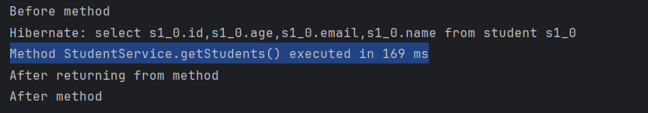

Explanation:
Element | Meaning
@Aspect | Declares this class as an Aspect
@Component | Registers it as a Spring-managed bean
@Around(...) | Advice that wraps method execution
execution(* ... ) | Pointcut expression — matches all methods in StudentService
ProceedingJoinPoint | Used in @Around advice to control method execution flow
joinPoint.proceed() | Calls the actual method; you can modify inputs/outputs if needed
joinPoint.getSignature() | Gives method name for logging

Limitations of Spring AOP:

- Only works with Spring-managed beans and not with other java objects.
- Only public and protected methods are intercepted, can’t work on private methods
- Only method-level interception is supported, don’t work on field level

🔹 SLF4J
SLF4J stands for Simple Logging Facade for Java.
It is not a logging framework itself, but a facade or abstraction for various logging frameworks such as:
- Log4j
- Logback
- java.util.logging (JUL)
- TinyLog, etc.

Uses:
- Decouples logging implementation from application code.
- You can switch between logging frameworks without changing your code.
- Promotes consistency and compatibility in large Java applications.

SLF4J setup:
<!-- SLF4J API -->
<dependency>
<groupId>org.slf4j</groupId>
<artifactId>slf4j-api</artifactId>
</dependency>

import org.slf4j.Logger;
import org.slf4j.LoggerFactory;
@SpringBootApplication
public class StudentManagementApplication {
private static final Logger logger = LoggerFactory.getLogger(StudentManagementApplication.class);
public static void main(String[] args) {
logger.info("Application started"); //using slf4j for logging
SpringApplication.run(StudentManagementApplication.class, args);
}
}

Why SlF4j is better than system.out.println
Feature | System.out.println | SLF4J with Logback
Logging Levels | ❌ Not available | ✅ TRACE, DEBUG, INFO, WARN, ERROR
Performance | ❌ Poor | ✅ Efficient (string formatting is lazy)
File/Appender Output | ❌ Console only | ✅ Files, databases, monitoring systems
Configurability | ❌ Hard-coded | ✅ Configurable via application.properties
Production Usage | ❌ Bad Practice | ✅ Industry Standard

